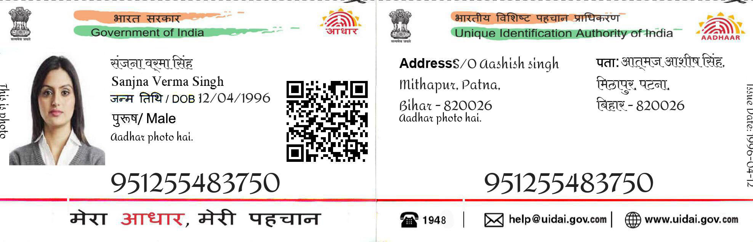ssssssssssssssss

Shobha Rawat

22-05-1990

female

1234 9876 3456

322

e

1234 9876 3456

Address-242 Ambedkar colony

Bijwasan